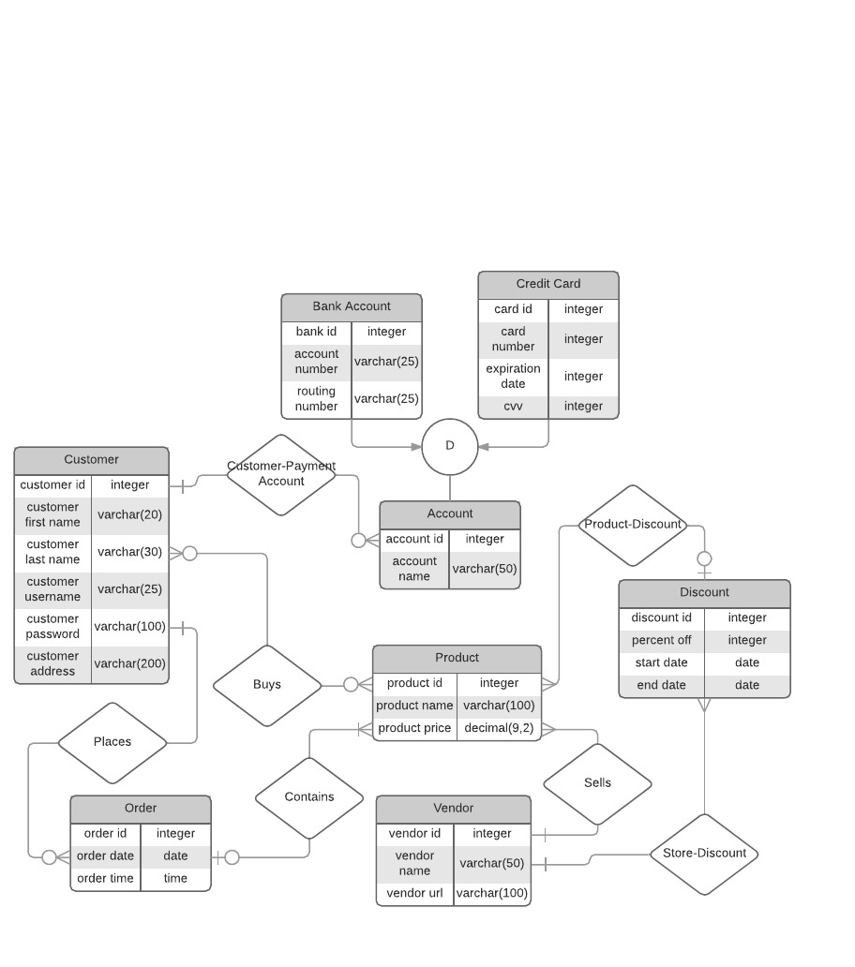

Customer(customer_ID, customer_first_name, customer_last_name, customer_user_name, customer_password, customer_address)

Order(order_ID, order_date, order_time, Customer.customer_ID)

Payment(account_ID, account_Name, Customer.customer_ID, Bank.bank_ID, Card.card_ID)

Bank(bank_ID, account_number, routing_number, payment.account_ID)

Card(card_number, expiration_date, cvv, payment.account_ID)

Product(product_ID, product_name, product_price, Vendor.vendor_ID, Discount.discount_ID, Order.order_ID)

Vendor(vendor_ID, vendor_name, vendor_URL)

Discounts(discount_ID, percent_off, start_date, end_date, Vendor.vendor_ID)

Constraints:

Not Null: customer_ID, order_ID, account_ID, product_ID, store_ID, discount_ID, bank_ID, card_ID

Unique: customer_ID, order_ID, account_ID, product_ID, vendor_ID, discount_ID, bank_ID, card_ID, customer_username, account_num, card_num

Functional Dependencies:

**Customer table:**

F= {customer_ID -> customer_first_name, customer_last_name, customer_address, customer_username, customer_password

customer_username -> customer_first_name, customer_last_name, customer_ID

}

**Order Table:**

F= {Order_ID -> order_date, order_time, Customer.customer_ID}

**Payment Table:**

F= {account_ID -> account_Name, Customer.customer_ID, Bank.bank_id, Card.card_id}

**Bank account Table:**

F= {bank_account_number -> bank_routing_number, payment.account_ID)

**Card Table:**

F= {card_number -> card_expiration_date, card_ccv, payment.account_ID}

**Product Table:**

F= {product_ID -> product_name, product_price, Vendor.vendor_ID, Discounts.discount_ID}

**Store Table:**

F= {store_ID -> store_name, store_URL,

store_URL -> store_ID, store_name}

**Discounts Table:**

F= {discount_ID -> percent_off, start_date, end_date, Vendor.vendor_ID}

Decomposition is not necessary because all relations are in BCNF and 4th Normal Form.

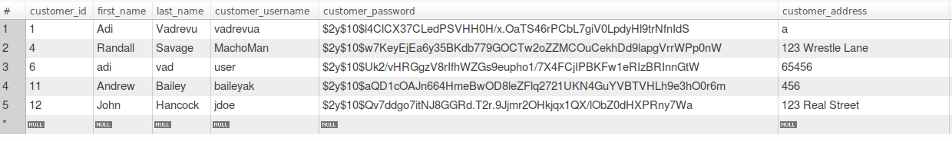Customer Table:

Order Table:

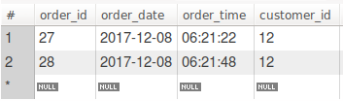

Payment Account Table:

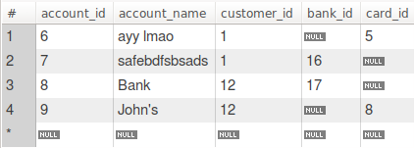

Bank Account Table:

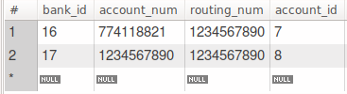

Card Account Table:

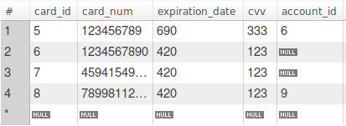

Discount Table:

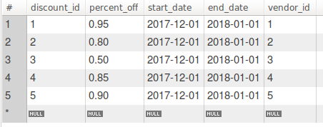

Vendor Table:

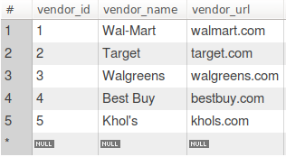

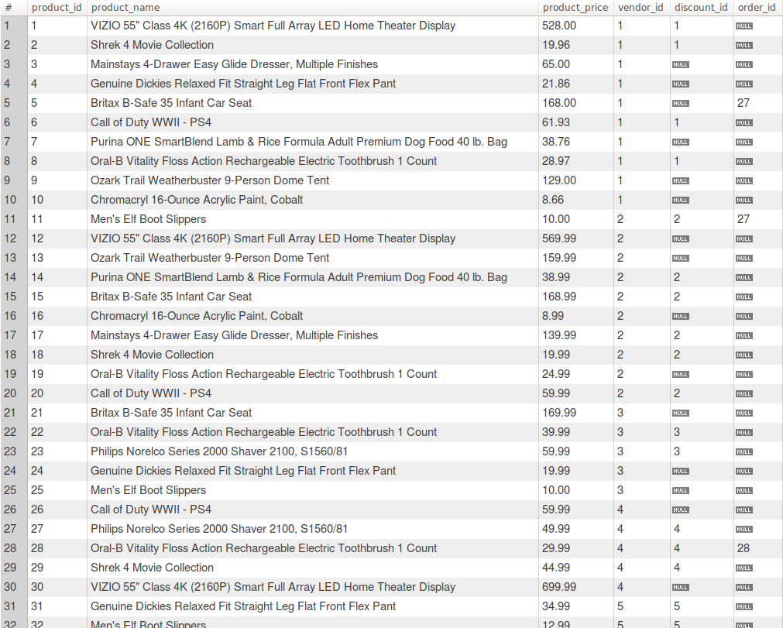Product Table: